1. Draw the V-Model diagram on paper or using any digital tool, and clearly label each phase with both the developer and tester roles involved at each step?
Ans:
I'll draw this as an interactive diagram so it's clear and easy to reference.
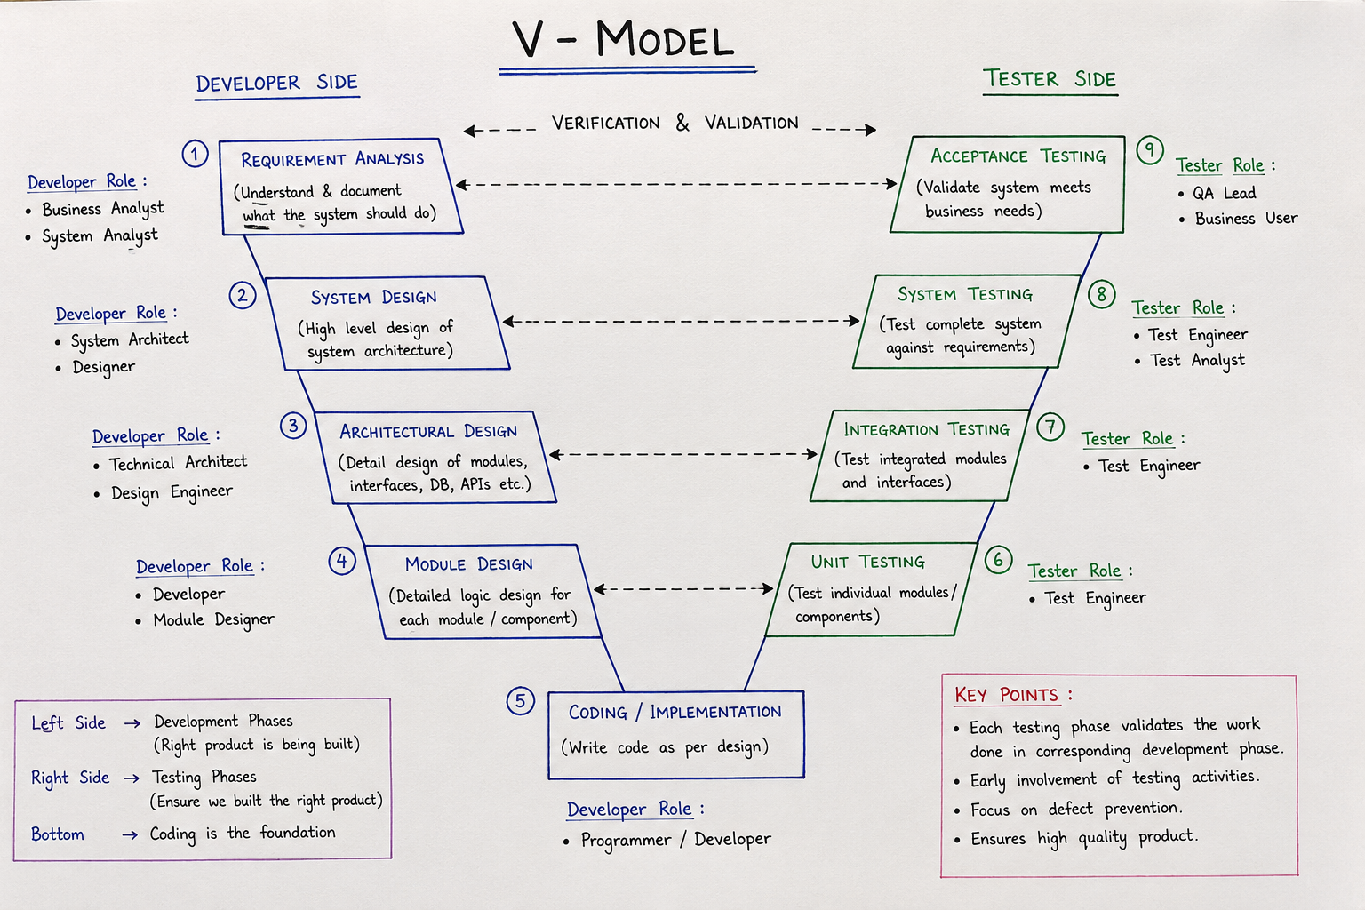

2. Pick any app you use daily (like Zomato, Instagram, or Paytm) and write a short table mapping each SDLC phase (Requirement, Design, Coding, Testing, Deployment, Maintenance) to a real activity that would happen for that app.
Ans:
Here’s a simple example using Zomato:
SDLC Phase | Real Activity in Zomato
1. Requirement | Identify the need for a food order tracking feature so customers can see their order status in real time.
2. Design | Design the tracking screen showing Order Confirmed → Preparing → Picked Up → Delivered.
3. Coding | Developers write code to connect the app with the restaurant and delivery partner systems and update order status.
4. Testing | Testers verify that order status updates correctly and check cases such as delayed delivery, cancelled orders, and network failure.
5. Deployment | Release the tested tracking feature to users through a new Zomato app version/update.
6. Maintenance | Fix bugs, improve performance, and add enhancements based on user feedback and production issues.

3. For each phase of the V-Model, list one specific testing activity that should be performed, using examples from a food delivery app (like Swiggy or Zomato).<br><br><em><strong>Hint:</strong> For example, during 'System Testing', you might test if the order placement works end-to-end.</em>
Ans: Here is a simple V-Model testing activity table using a food delivery app like Zomato/Swiggy:
V-Model Phase | Testing Activity | Food Delivery Example
1. Requirement Analysis | Review requirements and identify test conditions | Check whether the requirement clearly states that users must be able to order food and track delivery.
2. System Design | Prepare System Test Plan | Plan tests for the complete food-ordering system, including restaurant selection, cart, payment, and delivery tracking.
3. Architectural Design | Prepare Integration Test Cases | Plan how to test integration between Zomato, payment gateway, restaurant, and delivery partner systems.
4. Module Design | Prepare Unit Test Cases | Identify tests for individual modules such as Login, Cart, Coupon, and Payment.
5. Coding / Implementation | Perform Unit Testing | Developer tests whether the Calculate Total Price function correctly calculates food price, tax, discount, and delivery charges.
6. Unit Testing | Execute unit tests | Test the Coupon module with valid, expired, and invalid coupon codes.
7. Integration Testing | Test interaction between modules | Verify that after a successful payment, the order is correctly created and sent to the restaurant.
8. System Testing | Test the complete application end-to-end | Place an order from restaurant selection → cart → payment → order confirmation → delivery tracking.
9. Acceptance Testing | Validate against business/user requirements | A customer verifies that the app allows them to successfully order food, pay, and receive the delivered order as expected.

4. Compare the V-Model and RAD Model by listing 3 strengths and 2 weaknesses of each, focusing on how testing is handled in both models.
Ans:
Model | Strengths | Weaknesses
V-Model | 1. Testing starts early: Test planning begins during the requirement and design phases. | 1. Less flexible: Changes in requirements can make already-planned test cases and documentation costly to change.
 | 2. Clear testing stages: Unit, Integration, System, and Acceptance Testing are clearly defined and mapped to development phases. | 2. Testing comes after development of each component: Working software is not available for extensive testing until the corresponding development work is completed.
 | 3. Good traceability: Requirements can be directly linked to test cases, making coverage easier to track.
RAD (Rapid Application Development) | 1. Continuous testing: Testing occurs repeatedly during rapid development and prototyping. | 1. Less formal testing: Speed and frequent changes can result in less documentation and structured test planning.
 | 2. Early user feedback: Users can test prototypes and provide feedback, helping find usability problems early. | 2. Regression risk: Frequent changes to prototypes or components can introduce new defects, requiring repeated regression testing.
 | 3. Quick defect detection: Developers and users can identify and fix problems quickly during iterative development.

